Signing config generation steps:

1.Create keystore

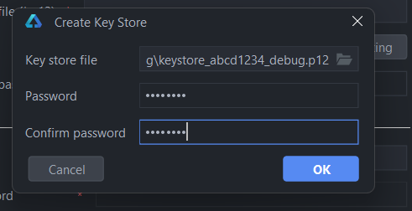

2.Generate key

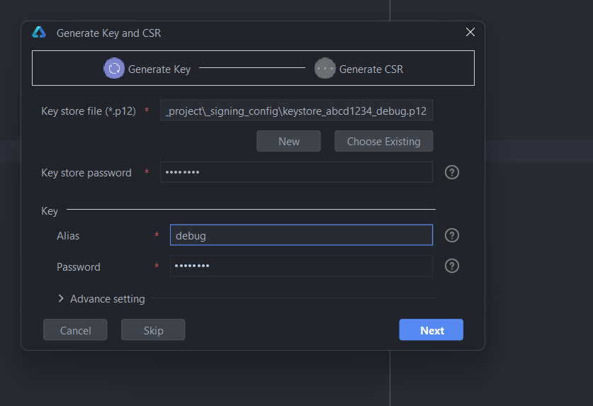

3.Generate csr file

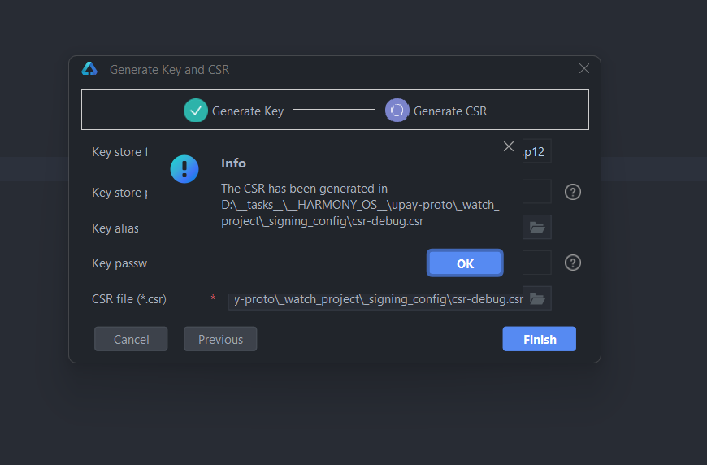

4.Upload csr to AG and download certificate

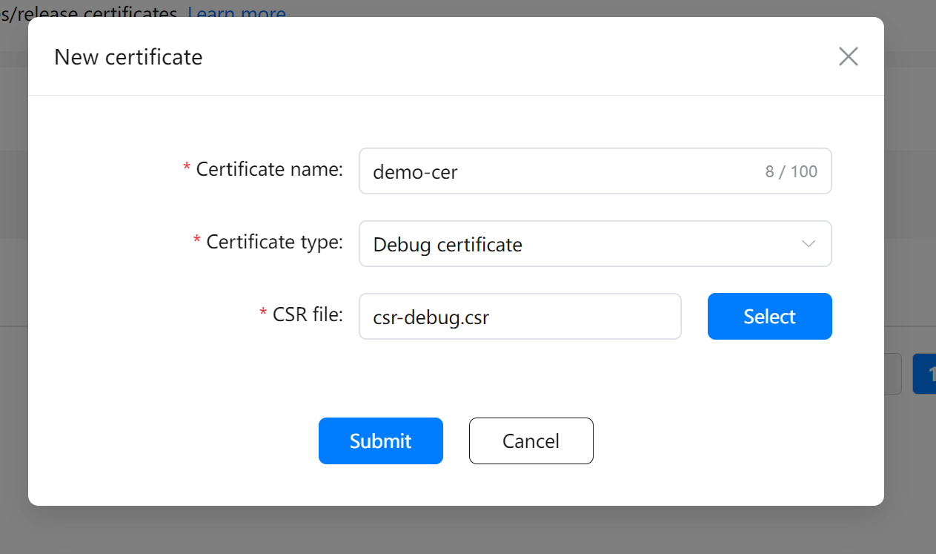

5.Add UDID of the watch

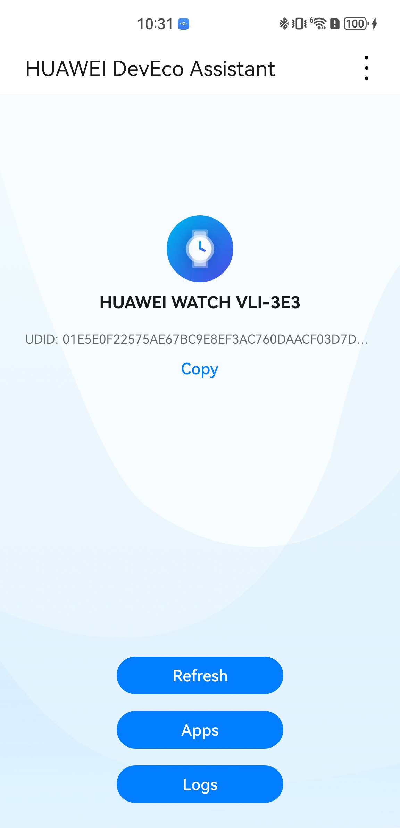

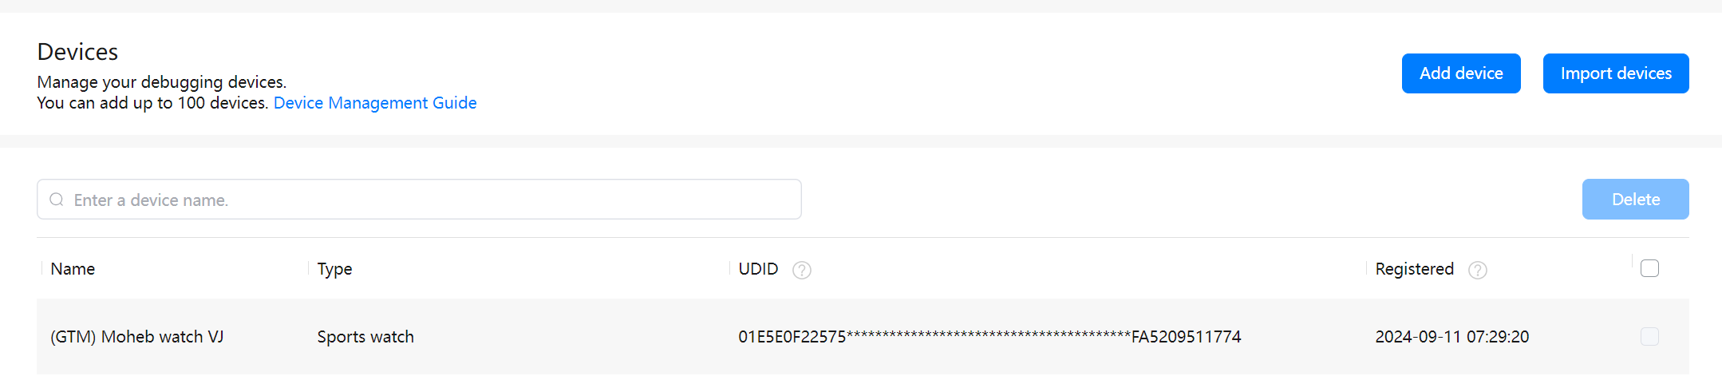

6.Create profile: select debug certificate 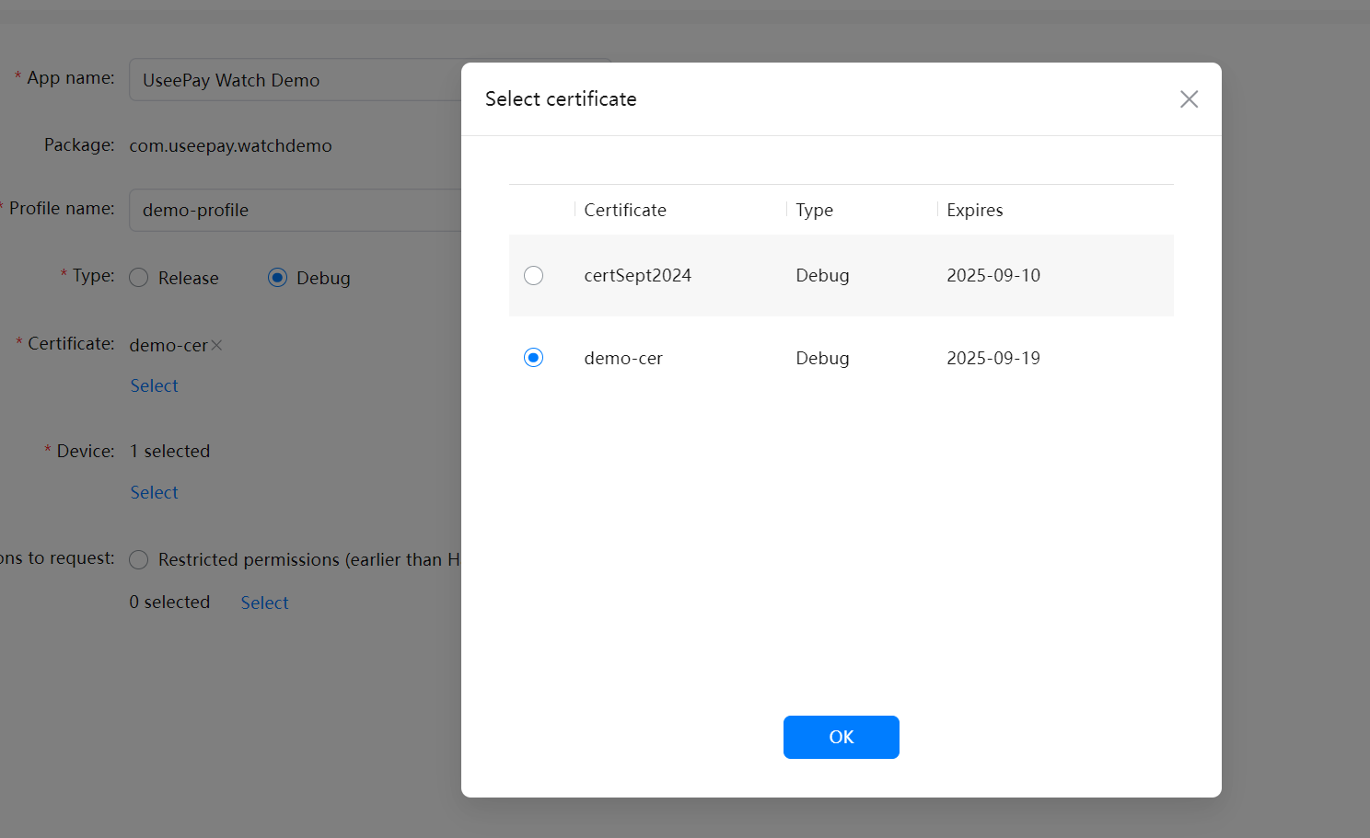

7.Select my device UDID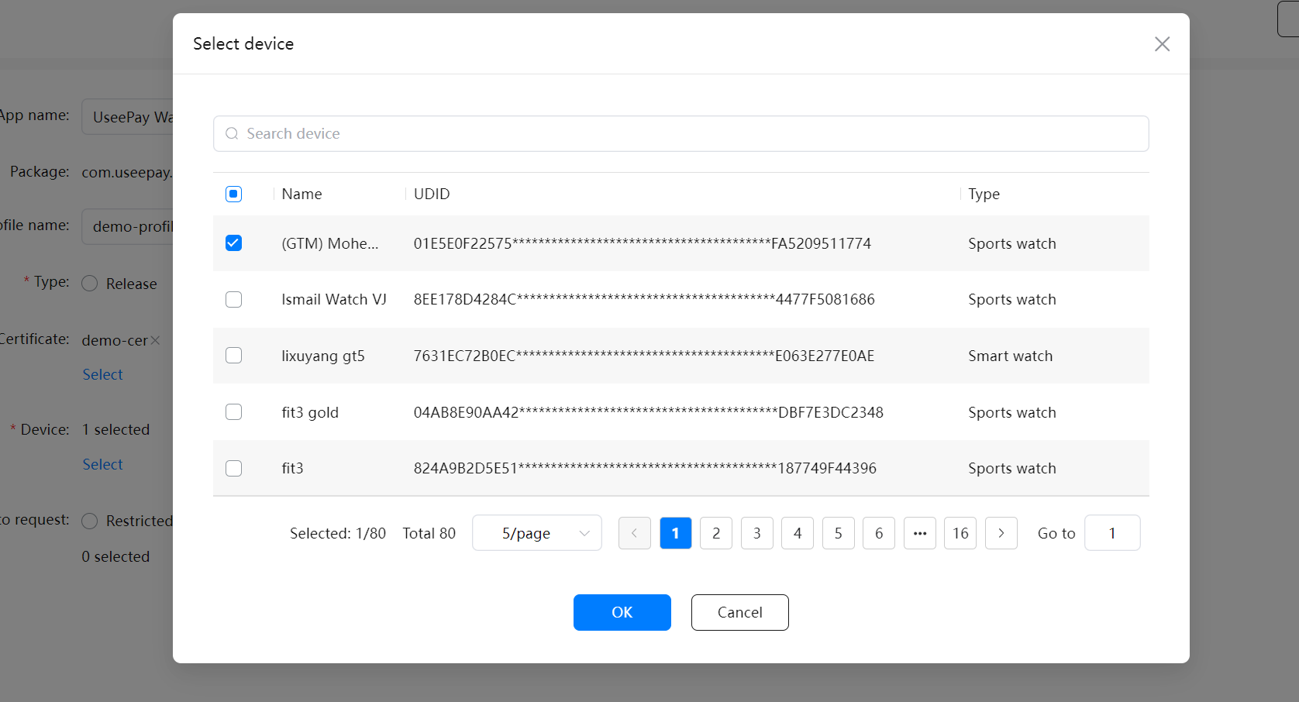

8.download Profile file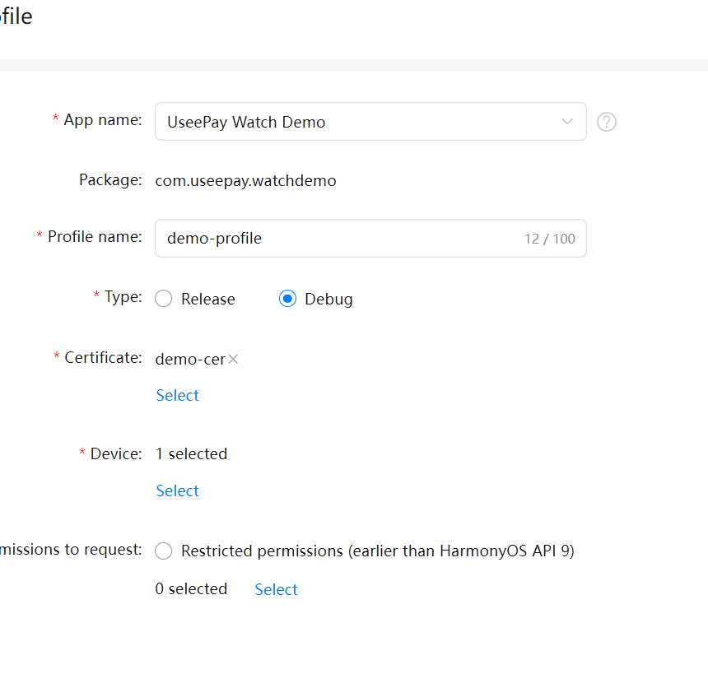

9.Generate singing config in DevEco

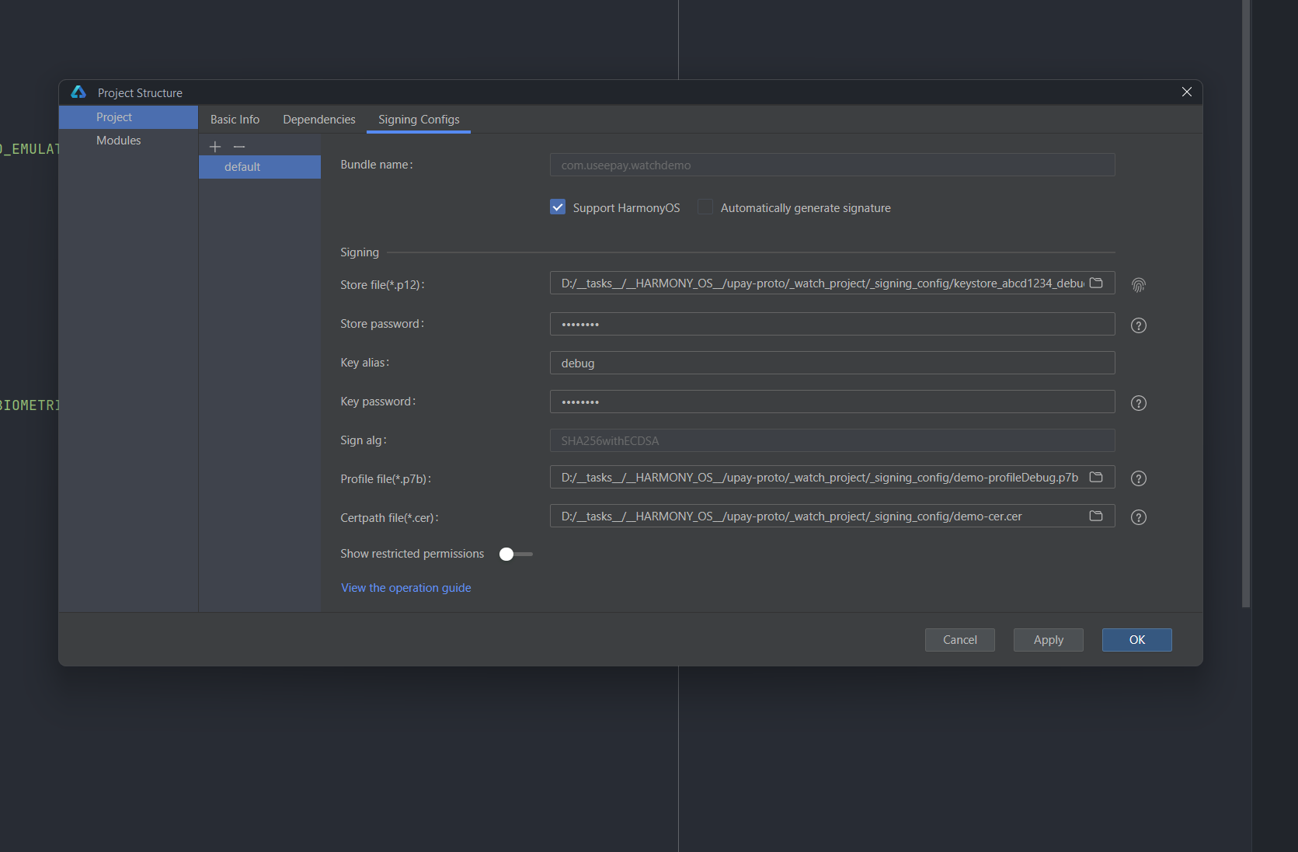

10.Generate signed .hap and send it to phone at “/sdcard/haps”

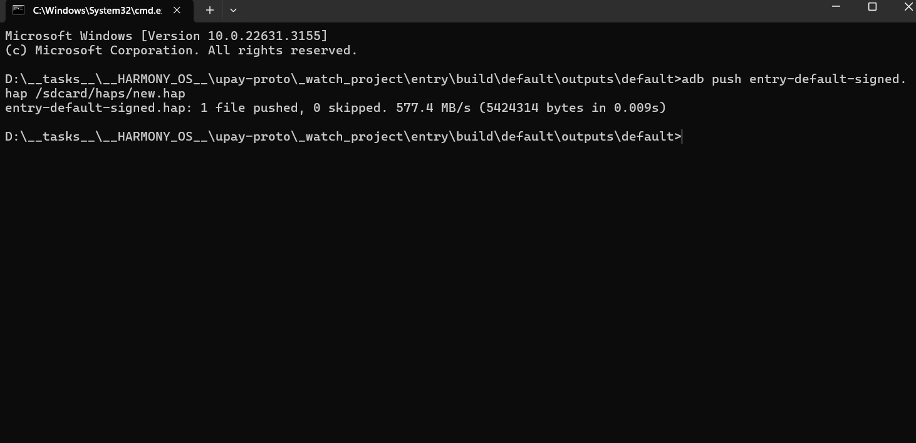

12.Open DevEco Assistant app, and install .hap ==>> always fails ! 